Automatic 4-shaft cutting machine ZRT-1300-G4

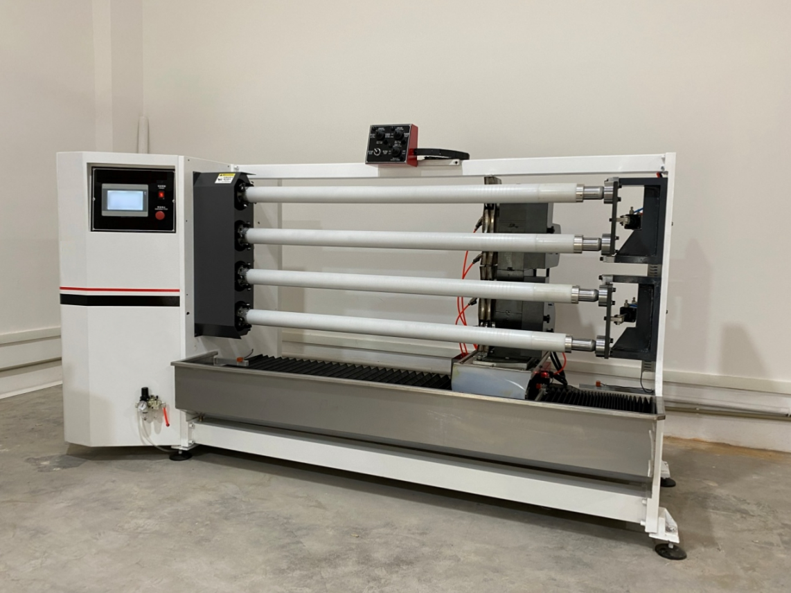

Basic Use：
This machine is designed for slitting narrow-width adhesive tapes, including electrical tape, washi tape, masking tape, double-sided adhesive tape and other adhesive materials. Features: Four spindles perform slitting simultaneously to greatly boost production efficiency; each circular cutter can be adjusted independently.

Product characteristics：
- Equipped with VECON PLC control system, supporting 12 working modes for cutting products of different widths. Users can freely select the starting and cutting end positions, with three adjustable cutter feeding speeds for slitting.
2.Main spindle driven by a 5500W Shihlin frequency converter; circular cutter driven by a 3700W Shihlin frequency converter. The system will immediately halt upon alarm to prevent cutter breakage.
3，Cross travel mechanism adopts HIWIN ball screw and linear guide, controlled by a 1000W Shihlin servo motor. Positioning tolerance within 1000mm travel: ±0.02mm.
4.Cutter feeding unit fitted with HIWIN ball screw and linear guide, driven by a 1000W servo motor to guarantee stable feeding force and high cutting precision.
5.Swing angle unit uses HIWIN ball screw with stepper motor control. Adjustable swing angle range: -9.5° ~ +9.5°.
6.QBQ surface treatment applied to cutter base and cross travel components to improve hardness, wear resistance, corrosion resistance and anti-deformation performance.
7.10-inch main touch screen for simple and intuitive operation.
8.Stainless steel diversion pipeline drainage system avoids silicone oil splashing during operation.

Main technical parameters：
Model | ZRT-1300-G4
paper core | 25/38/50/76=4strips  Customizable per customer requirements（interchangeable）available sizes:25/38/50/76=4 sets
Cutting Width（Min.）（Max.） | 0.5-1300mm
Max. Cutting Material Diameter | 150mm（Max material thickness 45mm; maximum spindle diameter varies by spindle model）
Max. Circular Cutter Diameter | 180mm
HMI Touch Screen | 10=inch
power supply | 380V（customizable 220V） 50/60HZ/8.8KW
air pressure | 5KG
Machine size | L2700 × W1100 × H1500 mm
Net Weight | 2T

Configuration parameters：
Item | Specification Configuration
Model | ZRT-1300-G4
Main Touch Screen | 10-inch
Frame Wall Plate | thickness 28 mm
PLC Controller | VECON
Main Spindle Motor | Three-phase asynchronous motor/ KETEMAI brand
Main Spindle Drive | 5500W Shihlin Frequency Inverter
Circular Cutter Motor | Three-phase asynchronous motor/ MODOLI brand
Circular Cutter Drive | 3700W Shihlin Frequency Inverter
Cross Travel Servo Motor | Shihlin Servo Motor
Cross Travel Servo Driver | Shihlin Servo Driver
Cutter Feed Servo Motor | Shihlin Servo Motor
Cutter Feed Servo Driver | Shihlin Servo Driver
Swing Angle Stepper Motor | Domestic brand
High-Speed Steel Cutter | SANSHI brand

Accessory Name | Brand / Specification
Air Circuit Breaker | CHINT
Switching Power Supply | TEND (Taiwan)
Photoelectric Sensor | Domestic brand
Proximity Switch | Domestic brand
AC Contactor | CHINT
Relay | OMRON
Push Button Switch | Domestic brand
Cutter Feed Ball Screw | HIWIN
Cross Travel Ball Screw | HIWIN
Swing Angle Ball Screw | HIWIN
Cutter Feed Linear Guide | HIWIN
Cross Travel Linear Guide | HIWIN

Configuration parameters：
Accessory Name | Brand / Specification Description
Solenoid Valve | Domestic brand
Air Cylinder | Domestic brand
Linear Guide Rail | HIWIN
Magnetic Switch | Domestic brand
Main Spindle (4 pcs) | Custom-made
Bearing | NSK
Machine Frame | Imported baking paint finish
Circular Cutters (Single-sided / Double-sided, high-speed steel / tungsten steel) | 4 pcs (selected according to processing materials)
Tool Kit | 1 set
Dial Indicator | 1 set
Cutter Alignment Rod | 1 pc
PE Tubing | 4 pcs

